[Week 3](https://www.coursera.org/learn/introduction-to-data-engineering/home/week/3)

Architecting the Data Platform

Data Ingestion or Collection Layer

Tools for data ingestion

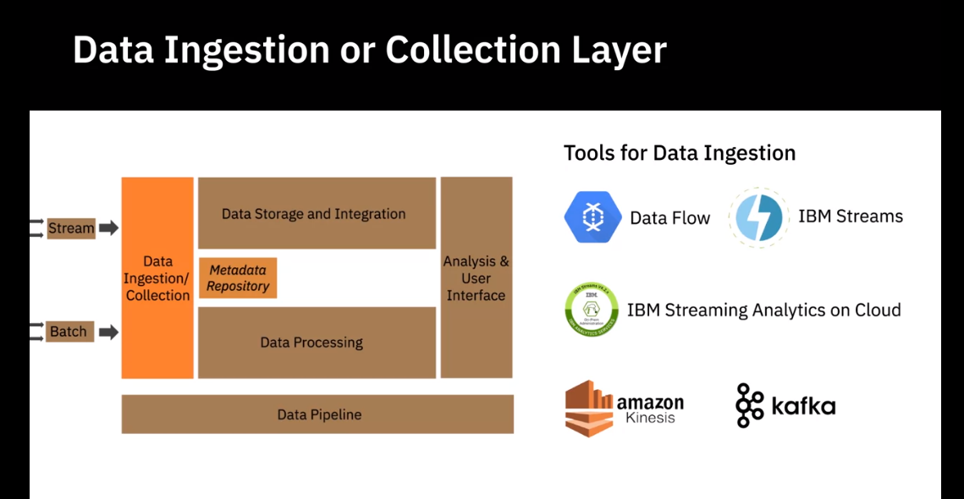

Data Storage Layer

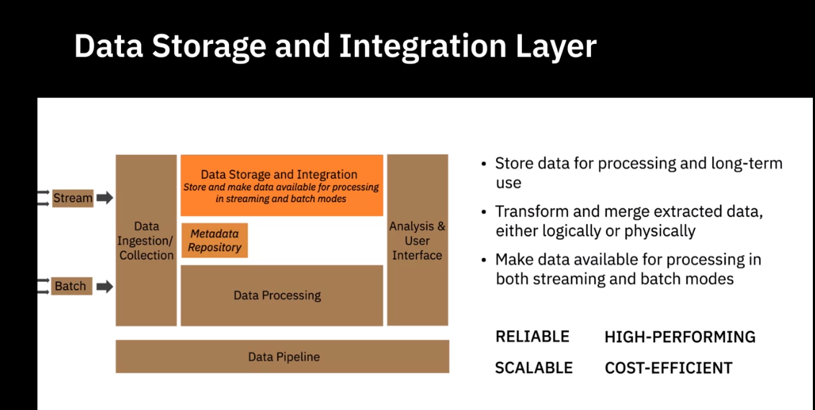

Ralational Databases

Database as a service

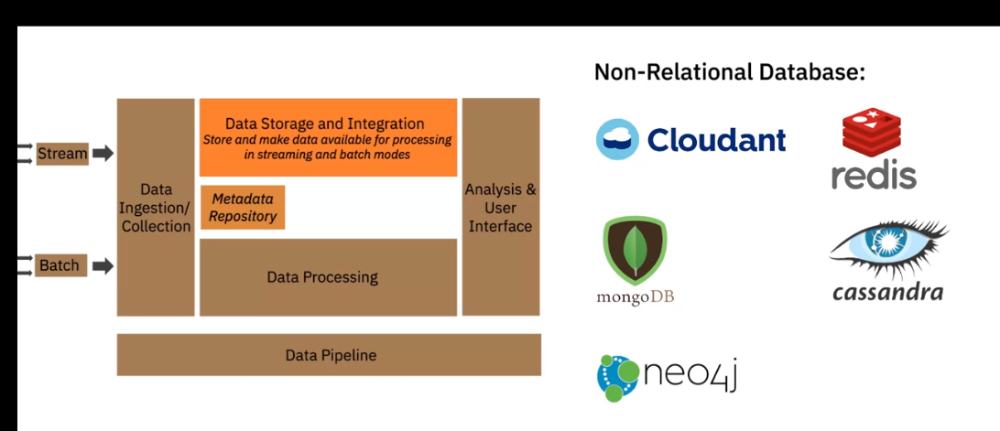

Integration Tools

Data Processing Layer

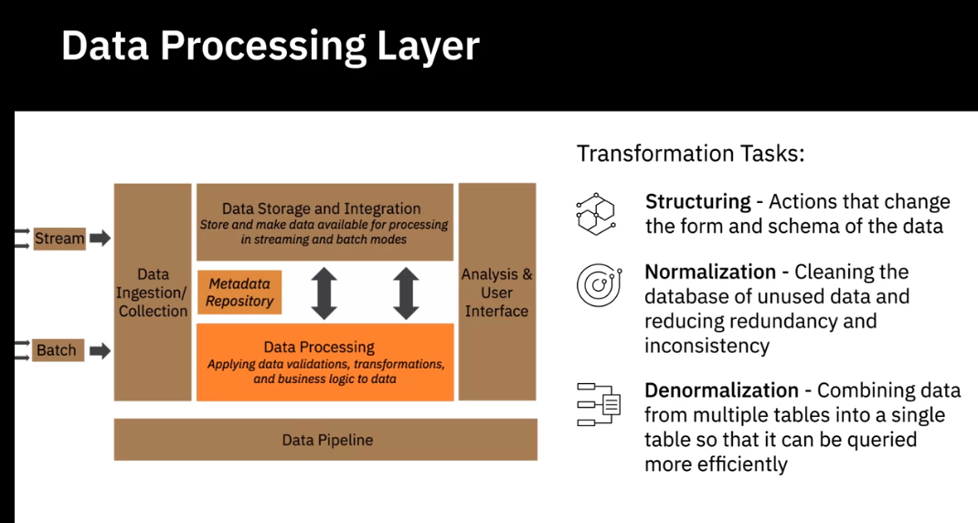

Analysis User Interface Layer

Data Pipeline Layer

**Factors for Selecting and Designing Data Stores**

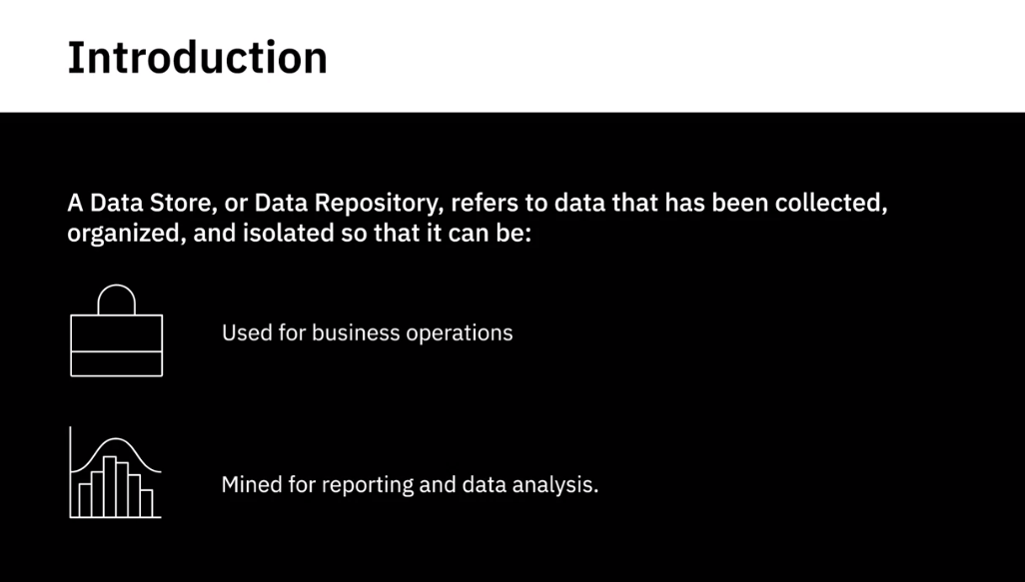

Considerations of designing a data store

Type of Data

Type of Database

Type of nosql database

Volume of Data

Intended use of Data

Intended use of Data

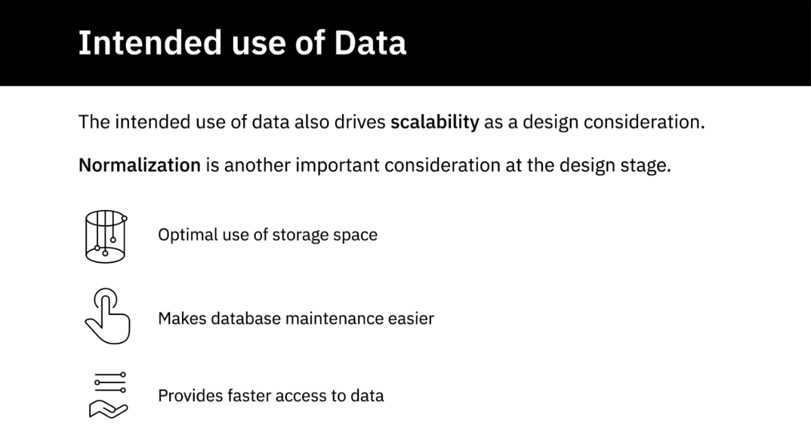

Normalisation: Transactional Data

Storage Considerations

